Firstly, download the Brain tumor data set from

1. Graphical user interface, application

   Description automatically generatedChose a file with the corresponding first 3 digits in your ID list
2. Apply at least 3 contrast measure on the selected image
   1. using **entropy** function

*code in matlab :*

**entropy( im2uint8(im) ); error**

1. Apply image **enhancement** using at least three methods
   1. imadjust ( image, [oldmin oldmax],[newmin newmax] )

*code in matlab :*

**imshow( imadjust (im ,[ im2double(min(min(im))) im2double(max(max(im))) ] , []));**

* 1. using **histogram equalization** :

*code im matlab :*

**histeq(im);**

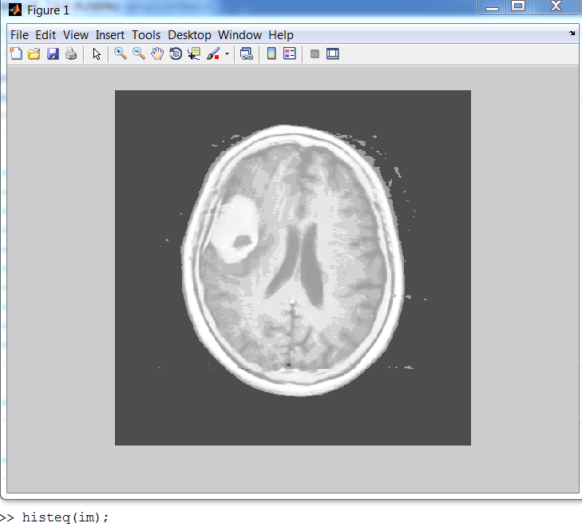

* 1. using adapting histogram equalization:

*code im matlab :*

**imshow (adapthisteq(im) );**

1. Measure the **signal to noise ratio** between the original and the enhanced image.
   1. With “imajust()” enhancing :

**snr (im , imadjust(im) );**

* 1. With “histeq()” enhancing :

**snr (im , histeq(im) );**

* 1. with “adapthisteq()” enhancing :

**snr (im , adapthisteq (im) );**

1. Apply edge extraction to the image. What kind of techniques should be applied before edge extraction?

Find edges using ‘canny’ method

*code im matlab :*

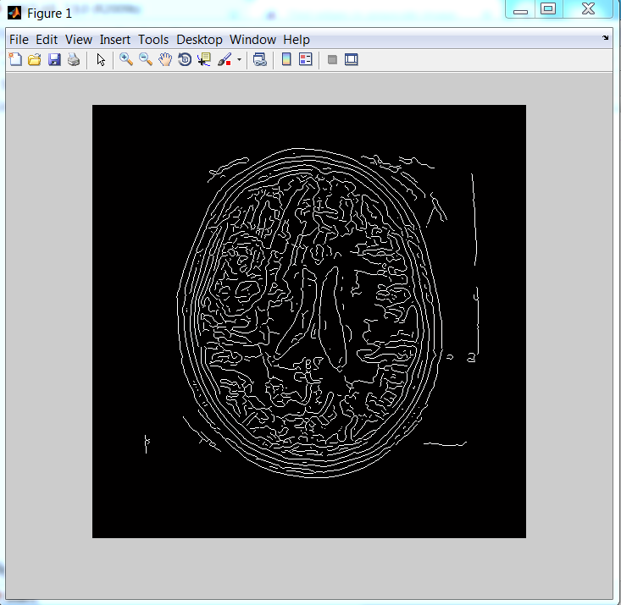**edge( im, 'canny' );**

1. Add noise to the image and reapply step 6. What will you note?

7.1 adding noise to image using **'gaussian'** method :

*code in matlab* :

**imshow( imnoise (im , 'gaussian' ) );**

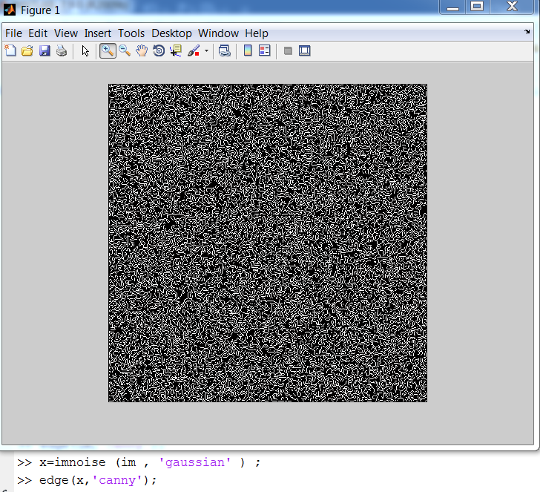7.2 find edges after adding noise :

1. Apply image segmentation to the image (original or enhance ) using :
   1. **Basic thresholding** :

*code in matlab* :

**im2bw ( myAdjust , 0.3) ;**

Note : “0.3” is the best number

* 1. Adaptive thresholding :

*code in matlab* :

**im2bw( adjust ,** **graythresh(adjust) );**

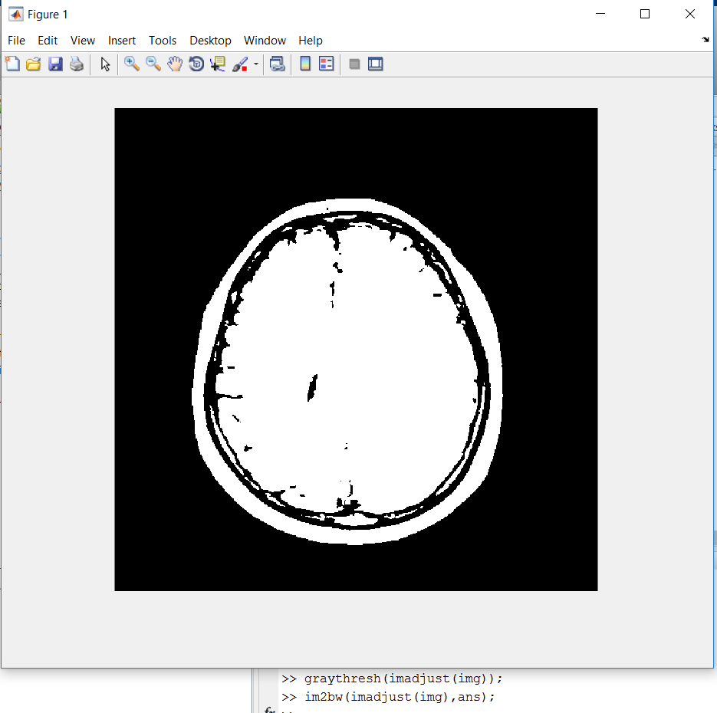

8.3 Multi-adaptive thresholding :

*code in matlab* :

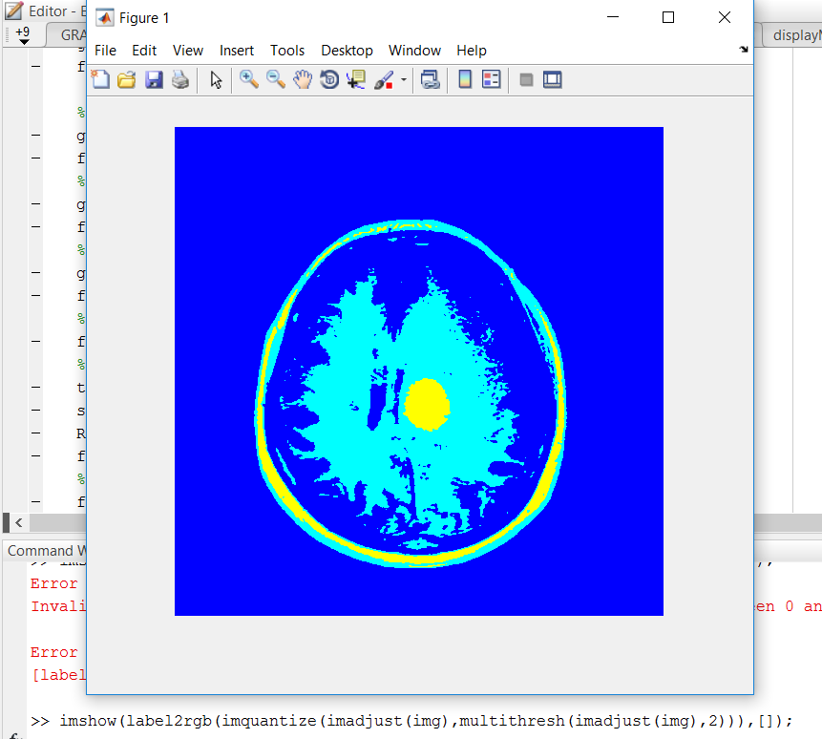**im2bw( adjust ,** **graythresh(adjust) );**